PROJECT DOCUMENTATION
Title: MCQ Generator Using FastAPI & Gemini API
Objective:
To build a Python-based system that can:
- Extract content from a syllabus-based PDF.
- Automatically generate MCQs (Multiple Choice Questions) from the content.
- Allow setting difficulty levels for the questions.
- To allow document reuse through upload-and-store mechanism.
- Use caching to avoid multiple API calls and save computation cost/time.
- To provide a user-friendly interface for both testing (via Swagger UI) and programmatic use (via Postman).

Technologies:
- Backend Framework: FastAPI (Python 3.11+)
- LLM API: Google Gemini 1.5 Flash via google.generativeai
- PDF Parsing: PyMuPDF (fitz)
- Uvicorn: ASGI server
- Testing Tools: Swagger UI (/docs), Postman
- File Management: json, os

API Endpoints:
Method | Endpoint | Description
POST | /upload-doc | Uploads a PDF file and returns a doc_id.
GET | /documents | Lists all uploaded files with their IDs.
POST | /generate-mcqs | Generates MCQs directly from uploaded PDF.
POST | /generate-mcqs/from-doc | Generates MCQs using previously uploaded document via doc_id.

Working:
- File Upload:
- Endpoint: POST /upload-doc
- User uploads a PDF file.
- File Listing:
  - Endpoint: GET /documents
  - Displays all uploaded documents with their unique ID.
- Generate MCQs (from file):
  - Endpoint: POST /generate-mcqs
  - Takes PDF file, difficulty, and number of questions.
  - Returns generated MCQs
- Generate MCQs (from doc_id):
  - Endpoint: POST /generate-mcqs/from-doc
  - Takes doc_id, difficulty, and number of questions.
  - Fetches PDF using ID and generates questions.
- Display:
  - MCQs are printed.
Sample Input:
PDF Biology Chapter1.pdf
difficulty:medium
num_questions:3
Sample Output:
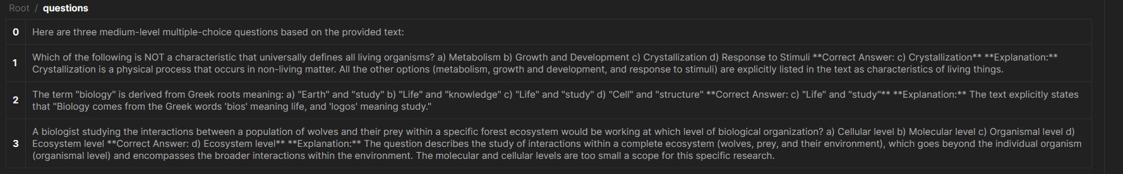

Conclusion:
This project demonstrates the practical integration of LLMs with backend APIs to automate real-world tasks like question generation. It streamlines content reuse, minimizes cost via caching, and provides both web and programmatic interfaces for ease of use. This is a step toward making smart educational tools using AI.

